JAVA ASSIGNMENT

**SUBMITTED BY,**

TAMILVANAN B.

2018503566.

MO BATCH.

08-25-2020.

1. **Write a Java program that finds the even elements between two arrays and creates a third array with those elements.**

**Program**:

import java.util.Scanner;

public class Third{

public static int[] remove(int arr[], int len){

int i, k;

int res[] = new int[len];

for(i = 0, k = 0; i < len ;i ++){

if(arr[i] % 2 != 0){

continue;

}

res[k ++] = arr[i];

}

return res;

}

public static void main(String... args){

Scanner sc = new Scanner(System.in);

int i, c = 0, k;

System.out.print("Enter the length of 1st array: ");

int n1 = sc.nextInt();

int[] arr1 = new int[n1];

System.out.print("Enter elements: ");

for(i = 0;i < n1 ;i++){

arr1[i] = sc.nextInt();

}

System.out.print("Enter the length of 2nd array: ");

int n2 = sc.nextInt();

int[] arr2 = new int[n2];

System.out.print("Enter elements: ");

for(i = 0;i < n2 ;i++){

arr2[i] = sc.nextInt();

}

int[] arr3 = new int[n1 + n2];

arr1 = remove(arr1, arr1.length);

for(i = 0; i < arr1.length; i++){

if(arr1[i] != 0){

arr3[i] = arr1[i];

c ++;

}

}

arr2 = remove(arr2, arr2.length);

for(i = 0, k = c; i < arr2.length; i++){

if(arr2[i] != 0){

arr3[k ++] = arr2[i];

}

}

for(i = 0; i < arr3.length; i++){

if(arr3[i] != 0){

System.out.print(arr3[i] + " ");

}

}

}

}

**OUTPUT:**

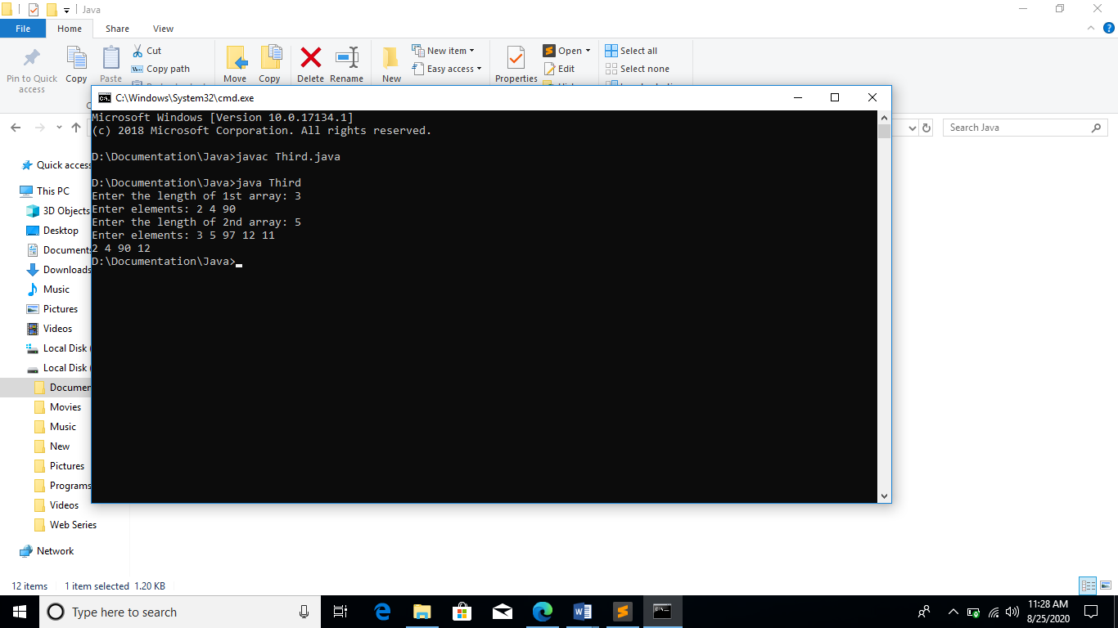

**2. You are an organizer of a technical symposium in your college. You have two participants list that consists of name of the students registered for online quiz and paper presentation. Write a java program that creates two array for storing the names of participants registered for online quiz and paper presentation. The program should list all the names of participants who have registered for both quiz and paper presentation.**

**Program**:

import java.util.*;

public class Quiz {

public static void main(String args[])

{

String[] paper = new String[100] ;

String[] quiz = new String[100] ;

Scanner scn = new Scanner(System.in) ;

System.out.println("Enter the no of names for Paper");

int lena = scn.nextInt() ;

System.out.println("Enter the no of names for Quiz");

int lenb = scn.nextInt() ;

int i ;

System.out.println("for paper");

for(i=0;i<lena;i++) {

paper[i] = scn.next() ;

}

System.out.println("for quiz");

for(i=0;i<lenb;i++) {

quiz[i] = scn.next() ;

if(Arrays.asList(paper).contains(quiz[i])) {

System.out.println(quiz[i]);

}

}

scn.close() ;

}

}

**OUTPUT**:

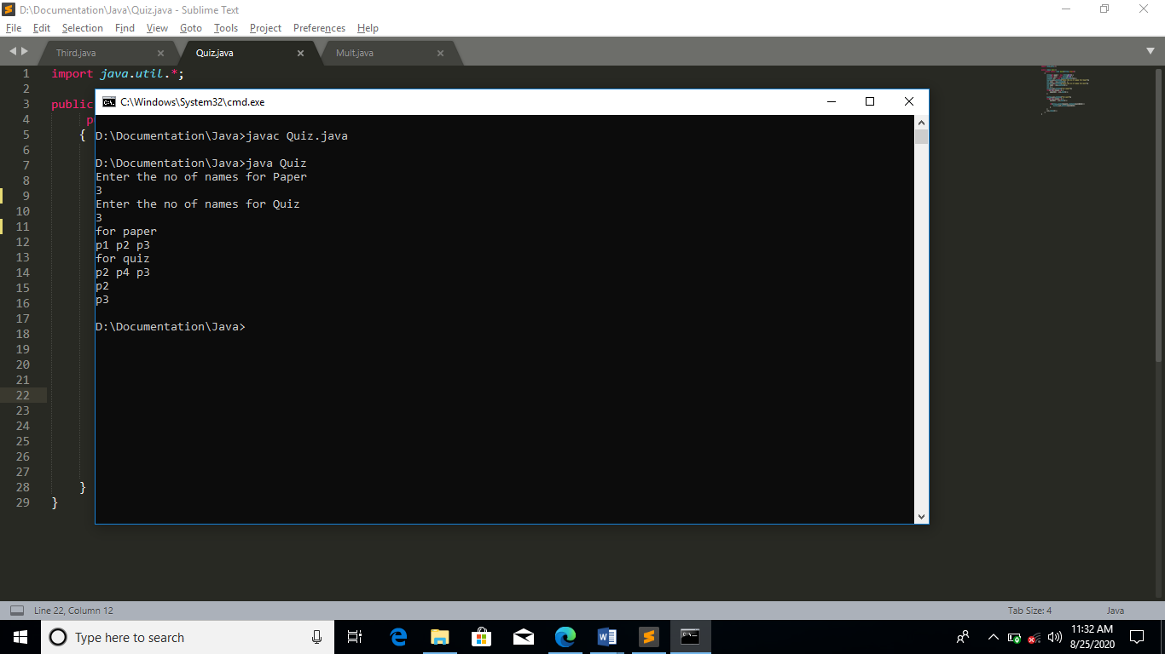

3**. Shoe problem.**

**Program**:

import java.util.*;

public class Mult{

public static void main(String args[]){

int a,b,c,ans;

int[] prices={2000,100,1000};

Scanner sc=new Scanner(System.in);

System.out.println("Enter the quantity of Bat , Ball and Sports Uniform to be purchased for the Women's team: ");

a=sc.nextInt(); b=sc.nextInt(); c=sc.nextInt();

ans=(prices[0]*a)+(prices[1]*b)+(prices[2]*c);

System.out.println("The total cost of equipments for the women's team is: "+ ans);

System.out.println("Enter the quantity of Bat , Ball and Sports Uniform to be purchased for the Men's team: ");

a=sc.nextInt(); b=sc.nextInt(); c=sc.nextInt();

ans=(prices[0]*a)+(prices[1]*b)+(prices[2]*c);

System.out.println("The total cost of equipments for the men's team is: "+ ans);

}

}

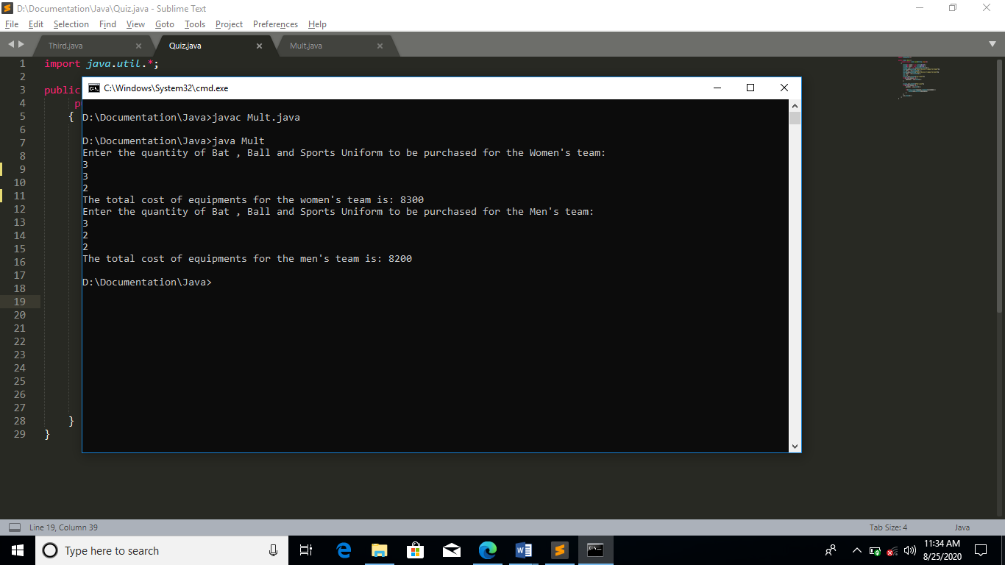**OUTPUT:**